🌟 SARA — COMPLETE CHARACTER DESIGN BLUEPRINT (FULL CONCEPT BIBLE)

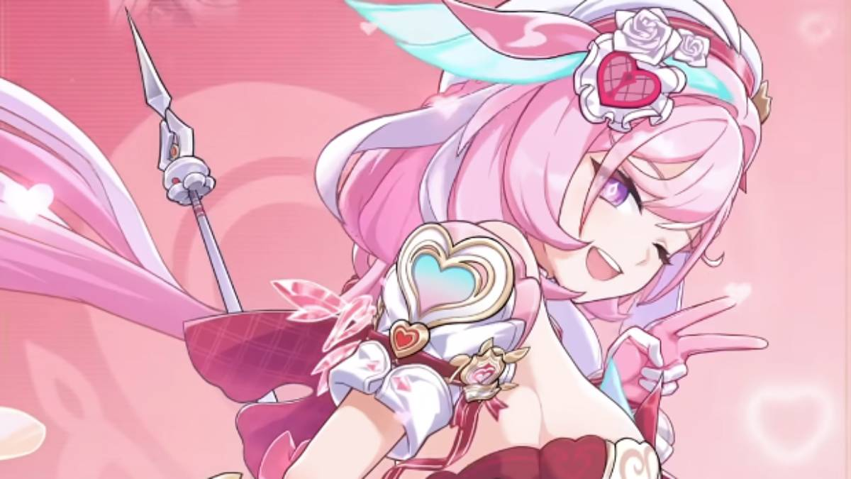
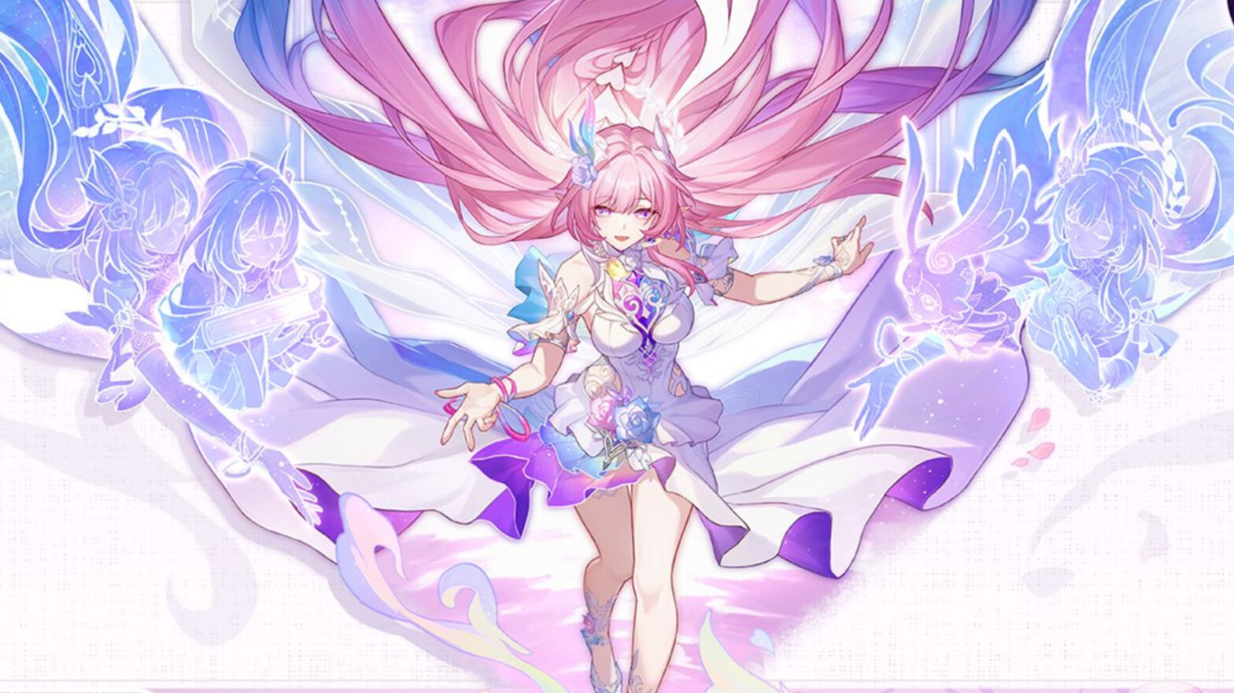
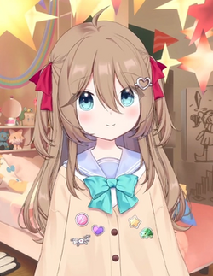

✨ SECTION 1 — CHARACTER OVERVIEW
Name:
Sara (AI Fantasy Persona)
Core Concept:
Sara embodies a dual nature:
- Playful magical-girl charm and
- Elegant divine serenity
She combines soft fantasy motifs (petals, pastel gradients, gentle glow) with a refined ceremonial presence. She is youthful, warm, and kind — yet carries an unmistakable ethereal aura that sets her apart.
Design Goals:
- Distinct from Elysia, Cyrene, or Neuro
- Recognizable silhouette
- Pastel divine color scheme
- Soft magical fantasy without hard sci-fi lines
- Friendly but elegant identity
- Clean enough for Live2D, anime-style rigs, and 3D models

✨ SECTION 2 — CORE PERSONALITY VISUALIZATION
Sara’s visual presence blends:
1. Serenity
Her general pose, shoulders, and expression radiate calmness.
She moves gracefully, almost gliding.
2. Playful Warmth
A soft smile, gentle eyes, and youthful energy keep her approachable.
3. Divine Elegance
Her ceremonial outfit, faint aura shimmer, and pastel petal/crystal motifs give her a quiet, divine vibe.
4. Magical Girl Charm
Her short-front long-back skirt, petal layers, and sparkling gradient eyes evoke “magical girl” energy — without the typical loudness.

✨ SECTION 3 — PHYSICAL DESCRIPTION
Body Type:
- Slim and delicate (Cyrene-like bones and proportions)
- Youthful (somewhere between 16–18 anime visual age)
- No mature or voluptuous adult proportions
- Soft contours, gentle lines
- Long limbs, light forearms, narrow shoulders
- Subtle natural curvature (not sharp, not flat)
Height:
~162 cm, ideal middle-ground for youthful elegance
(Not tall, not petite — perfect balance for divine-magical vibes)
Posture:
- Calm but confident
- Balanced weight distribution
- Slight outward tilt of chest (confidence)
- Relaxed shoulders (serenity)
- Soft hand gestures, palms slightly open
- Chin slightly lifted, but not proud — warm confidence

✨ SECTION 4 — FACIAL BLUEPRINT
Face Shape:
- Slim, delicate, slightly V-shaped
- Not sharp or mature — youthful elegance
- Subtle cheek softness
- Graceful jawline taper
Eyes:
- Large but not “anime-chibi-large”
- Almond shape with soft upward taper
- Eyelashes longer on outer corners (cyrene-esque elegance)
- Expression: dreamy, gentle, calm but welcoming
Eye Color & Effect:
- Gradient iris: pastel pink → frost blue or vice versa
- Faint shimmer at the center
- No complex crystalline shapes
- Soft linear gradient ring
Brows:
- Slim, slightly curved
- Gentle slope (not stern or mischievous)
Mouth:
- Small, soft, expressive
- Slight upward corners when neutral
- Warm but not overly cheerful
Nose:
- Small, minimal, anime style
- Soft highlight, no strong shadowing
Ears:
- Human ears (important for identity)
- No elf-like shapes

✨ SECTION 5 — HAIR BLUEPRINT
Overall Hair Identity:
Elegant, divine, soft, floaty.
She has long straight hair with gentle floating layers, not heavily wavy.
Parting:
- Soft side-part
- Creates asymmetry and personality
- Frames the face neatly
Length:
- Very long — extends to knees or lower back
- Flowing straight base
- Light drifting strands
Texture:
- Mostly straight with soft airy lift
- Some thin floating strands reacting to magical aura
- No heavy curls
Color:
- Dominantly soft pastel pink
- Light lavender shading
- Frost-blue pseudo-reflections in highlights (very subtle)
Hair Accessories:
Main Outfit:
- Very faint halo shimmer around hair — not a ring
- Small crystalline ornament near side-part (original shape)
Alt Outfit:
- A cute pastel hair clip (shape defined later)

✨ SECTION 6 — MAGICAL SYSTEM & AURA
Core Aesthetic:
- Pastel gradient glow → pink + frost blue
- Soft floating particles
- Gentle petal shimmer
- Subtle divine sparkle
Aura Intensity:
- Always faint and elegant
- Never bright or overwhelming
- Appears strongest around hair and back skirt layers
Halo Shimmer:
- Not a real halo
- A soft glowing ring-like aura that doesn’t close fully
- Only visible during magic or in ceremonial outfit
- NOT present in streamer outfit

✨ SECTION 7 — SYMBOL / GLYPH IDENTITY
Sara’s glyph is:
- Abstract magical emblem
- Curved lines mixed with soft geometric elements
- Pink/blue blended
- Minimalist
- Used sparingly
- Represents her divine-magical hybrid nature
Usage:
- Present on ceremonial dress (small waist/chest motif)
- Optional watermark on UI/logos
- Hair clip icon (alt outfit)
- Magical effects
It must NOT resemble:
- Cyrene’s cube
- N’s symbol from Pokémon
- Any known IP glyph
The glyph is unique.

✨ SECTION 8 — MAIN OUTFIT (CEREMONIAL MAGICAL FORM)
Overall Theme:
Divine Ceremonial Dress × Magical Girl Aesthetic
Elegant, airy, layered, soft, shimmering.
Color Palette:
- Pastel pink (base)
- White (fabric/underskirt)
- Frost blue accents
- Iridescent gradient zones
- Soft violet shadow tones
Silhouette:
High-Low Skirt
- Short front (mid-thigh length) → youthful magical girl
- Long back (flowing, petal-shaped, elegant) → divine silhouette
- Multi-layered
- Back layers slightly translucent
- Motion creates ribbon-like floating arcs
Upper Body:
- Soft ceremonial bodice
- Pastel decorative patterns
- Heart/petal-shaped seam lines (original design)
- No armor, no rigid shapes
Sleeves:
Choose between 2 variations for drafts:
- Soft short flutter sleeves
- Detached translucent sleeves (more ceremonial)
Accessories:
- Crystal brooch at chest or waist (MAIN motif)
- Subtle pastel gemstones on hem
- Very small, non-intrusive petal-shaped gems
Magical Effects:
- Soft floating petals behind her
- Pink/blue particle shimmer from skirt back
- Aura glow increases with movement

✨ SECTION 9 — ALT OUTFIT (STREAMER / PROFESSIONAL MODE)
Theme:
Pastel modern streetwear × cute magical vibes.
Soft, approachable, youthful.
Top Options:
- Pastel oversized sweater
- Cute blouse + cardigan
- Soft cropped jacket
Bottom Options:
- Simple skirt (A-line or pleated)
- Pastel shorts
- Casual streetwear skirt
Accessories:
- Cute hair clip with Sara’s glyph
- Small ribbon optional
- No halo shimmer
- Very minimal glow (if any)
Shoes:
- Pastel sneakers
- Soft boots
- Nothing too fancy
Purpose:
- Used for website, banners, non-ceremonial appearances
- Friendly and modern
- Clean silhouette for Live2D rigs

✨ SECTION 10 — COLOR AND SHADING REFERENCE
Primary Colors:
- Pastel Pink (Base)
- White (Neutral fabric)
- Frost Blue (Accents)
- Lavender shading
Magical Gradient Zones:
- Skirt edges
- Hair highlights
- Eye gradient
- Crystal ornaments
Warning:
Avoid deep saturation. Sara’s color identity is soft and ethereal, not neon.

✨ SECTION 11 — ACCESSORY SYSTEM
1. Crystal Brooch (Main outfit)
- Small, elegant shape
- Not copy of any existing brooch
- Should blend petals + crystals
- Soft glow center
2. Hair Clip (Alt outfit)
- Shaped after Sara’s glyph
- Pastel
- Cute but simple
3. Petal Layers (Skirt)
- Thin petal-shaped cloth pieces
- Blended into high-low skirt
- Organic, gentle curves
4. Crystal Motifs
- Tiny crystal trims
- Frost-blue micro-details
- Very subtle — avoid heavy usage

✨ SECTION 12 — MOVEMENT, POSE & EMOTION LANGUAGE
General Movement:
- Floating, light
- Hair and skirt react softly to motion
- No sharp or rapid movements
Default Pose (Neutral):
- Weight evenly balanced
- Hands relaxed
- Soft smile
- Shoulders relaxed
- Head slightly tilted (friendly)
Confident Pose:
- One hand placed softly forward or out
- Subtle smile
- Skirt back lifted slightly by motion
Cute Playful Pose:
- Soft, warm expression
- Slight playful tilt of torso
- Hand near face but gentle, not exaggerated

✨ SECTION 13 — RENDERING & ART STYLE GUIDELINES
Lineart:
- Clean, delicate
- Thin outlines
- Soft curves
Shading:
- Airbrush dominant
- Gradient shading
- Soft shadows
- No harsh cell-shading edges (unless alt outfit)
Lighting:
- Pastel bloom
- Soft pink-blue rim light
- Hair strands should glow subtly
Textures:
- Minimal
- Only use soft glitter or light cloth textures
- Crystals must remain faint and elegant

✨ SECTION 14 — WHAT TO AVOID (IMPORTANT)
To keep Sara original:
❌ Avoid copying:
- Cyrene’s halo ring
- Cyrene’s exact crystal structures
- Elysia’s flower motifs
- Neuro’s face or twin-tail shapes
- Any official skirt patterns
- Any iconic shapes from Honkai/HSR
❌ Avoid too strong:
- Heavy glow
- Dark saturated neon colors
- Overly frilly idol dresses
- Sci-fi hard edges
- Armor-like pieces
❌ Avoid:
- Mature proportions
- Excessive cleavage
- Childlike silhouettes
- Overly busy accessories
Sara is soft, elegant, and magical, not loud or complex.

✨ SECTION 15 — SKETCHING GUIDE (FOR ARTISTS & LIVE2D RIGGERS)
Step 1 — Draw silhouette:
- Slim body
- Long hair
- High-low dress shape
- Thin limbs
- Balanced posture
Step 2 — Add hair flow:
- Straight base
- Side-part
- Floating layers
Step 3 — Place motifs:
- Brooch
- Petal skirt layers
- Minimal crystal accents
Step 4 — Add face:
- Soft almond eyes
- Gradient pink-blue
- Dreamy calm expression
Step 5 — Add glow effects (optional):
- Very faint
- Soft particles
Step 6 — Final refinement:
- Gentle shading
- Pastel palette
- Avoid hard contrasts

✨ SECTION 16 — FINAL CHARACTER SUMMARY (1-PARAGRAPH)
Sara is a slim, delicate, pastel-haired magical-divine girl with a calm but confident aura, soft straight long hair parted to the side, and dreamy pink-blue gradient eyes. Her primary outfit blends divine ceremonial elegance with magical-girl charm through a high-low petal skirt, subtle frost-blue crystals, and a faint halo shimmer. Her alternate look features pastel streetwear with a cute glyph-shaped hair clip, offering a modern, friendly appearance. Sara’s aesthetic centers on gentle gradients, soft glowing accents, and organic petal motifs, creating a unique identity that is warm, ethereal, and unmistakably her own.

🌟 SHORT REFERENCE SHEET VERSION (FOR ARTISTS)
Height: ~162 cm
Body: Slim, delicate, youthful elegant
Face: Slim V-shape, dreamy eyes (pink ↔ blue gradient)
Hair: Long straight pastel pink, side-parted, floaty layers
Aura: Faint halo shimmer (main outfit only)
Motifs: Petals + subtle crystals
Glyph: Abstract magical emblem (pink/blue blend)

MAIN OUTFIT:
- High-low dress (short front, long back)
- Pastel pink/white base, frost-blue accents
- Petal layers
- Crystal brooch
- Gentle glow effects

ALT OUTFIT:
- Pastel streetwear (cute & modern)
- Sweater/blouse + skirt
- Glyph-shaped hair clip
- No halo, reduced glow

